TITLE OF PAPER [FONTS ARIAL 14 Bold]
Presenting Author’s Name (Surname with Initials) [Arial 12]
Co-Author’s Name/s (Surname with Initials) – if any [Arial 12]
Affiliation/University/Institute, Country [Arial 11 Italic]
<Author’s email> [Arial 11 Italic]

ABSTRACT [Arial 12 Bold, maximum 300 words]
An abstract is a single paragraph, without indentation, a compendious summary of a paper's substance including research question, background, purpose, methodology, results, and conclusion in 250 to 300 words. The first page of the submission should only contain the abstract (Background, Methods, Results, and Conclusion) and should identify a preferred sub-theme, track and abstract category. It should not bear any marks identifiable to the author or authors. The abstract must be no longer than 300 words in English. The second page should contain the author’s name, title, affiliations, and location (city, state, and country) of each author; indicate the corresponding author using the email address of the corresponding author. In formatting the text of the Abstract, a standard font, such as 11pt, Arial should be used. An abstract is a single paragraph, without indentation, a compendious summary of a paper's substance including research question, background, purpose, methodology, results, and conclusion in 200 to 300 words. The first page of the submission should only contain the abstract (Background, Methods, Results, and Conclusion) and should identify a preferred sub-theme, track and abstract category. It should not bear any marks identifiable to the author or authors. The abstract must be no longer than 300 words in English. The second page should contain the author’s name, title, affiliations, and location (city, state, and country) of each author; indicate the corresponding author using the email address of the corresponding author. In formatting the text of the Abstract, a standard font, such as 11pt, Arial should be used. The British English style is recommended.

Keywords: Single, Paragraph, Summarises, words indentation (maximum 6 words)

Introduction (ARIAL 14pt., bold)
The main text, (ARIAL 11pt., alignment in block, spacing 1,0) text, text, text, text, text, text, text, text, text, text, text, text, text, text, text, text, text, text, text, text, text, text, text, text, text, text, text, text, text, text, text, text, text, text, text, text, text, text, text, text, text, text, text, text, text, text, text, text, text, text, text, text, text.
Figure 1: Figure description (ARIAL 10pt., centred, italics)
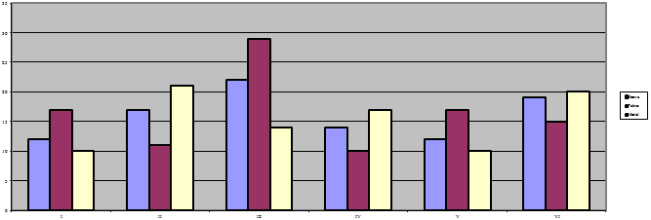
Source: (ARIAL 10pt. italics)
Text, text, text, text, text, text, text, text, text, text, text, text, text, text, text, text, text, text, text, text, text, text, text, text, text, text, text, text.

Title of the 2nd level (ARIAL 12pt., bold)
Text, text, text, text, text, text, text, text, text, text, text, text, text, text, text, text, text, text, text, text, text, text, text, text, text, text, text, text, text, text, text, text, text, text, text, text, text, text, text, text, text, text, text, text, text, text, text, text, text, text.

Title of the 3rd level (ARIAL 12pt., bold)
Text, text, text, text, text, text, text, text, text, text, text, text, text, text, text, text, text, text, text, text, text, text, text, text, text, text, text, text, text, text, text, text, text, text, text, text, text, text.

Tables and figures should be numbered and references to them must be in the text. Acceptable labelling for a table is Table 1 and Figure 1 for a figure.
Table 1
Table description (ARIAL 10pt., italics)

Titles | Items | Details
Arial10pt | Arial10pt | Arial10pt
Arial10pt | Arial10pt | Arial10pt
Total | x | x

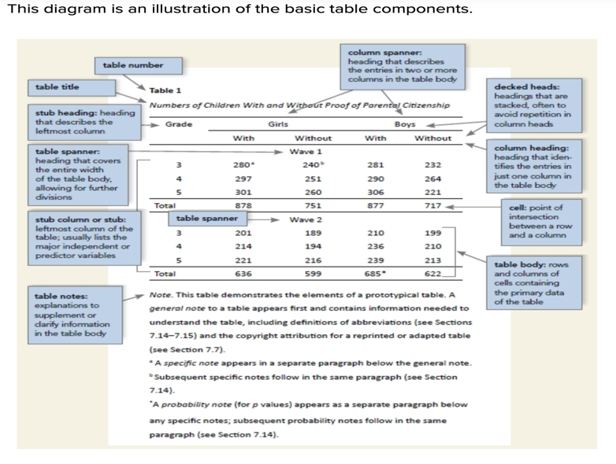
For detail, please visit https://apastyle.apa.org/style-grammar-guidelines/tables-figures/tables

Note/ Source: (ARIAL 10pt., italics)

Equations
Equations (refer with: Eq. 1, Eq. 2,...) should be placed in the middle, denoted by numbers in round parentheses and transformed by equation conversion manager, do not use Print Screen or jpg format. For example:
(1)

Body of paper (ARIAL 14pt., bold)
The article must be divided into chapters. Introduction and conclusion are obligatory.
It is recommended to adjust the body of the paper to the common organisation structure of scientific papers – IMRaD (Introduction, Methods, Results and Discussion).

Conclusion (ARIAL 14pt., bold)

Acknowledgment (ARIAL 12pt. bold): Optional
This paper is an output of the science project…
References (ARIAL 11pt)
References in text should have this form for example:
1 author: Krugman (2012) or (Krugman, 2012)
1 author and the same year of publication: Hoffman (2012, A) and Hoffman (2012, B)
(Hoffman, 2012, A); Hoffman, 2012, B)
2 authors: Krugman & Hoffman, (2014) or
(Krugman and Hoffman, 2014)
3 authors or mote: Hoffman et al. (2012) or
(Hoffman et al., 2012)

References (ARIAL 14pt., bold)
For each work shown in the list of references there must be a reference in the text. All citations in the text and all references must meet APA styles (American Psychological Association 6th edition – more information http://www.apastyle.org and https://apastyle.apa.org/instructional-aids/reference-guide.pdf

Common APA 7th Edition Reference Examples
- Book: Author, A. A. (Year). Title. Publisher. https://doi.org/
- Journal Article: Author, A. A. (Year). Title. Journal Title, Vol(Issue), pages. https://doi.org/
- Website: Author, A. A. (Year, Month Day). Title. Website Name. URL
- Edited Chapter: Author, A. A. (Year). Title. In Editor (Ed.), Book Title (pp. xx–xx). Publisher.

Footnote Arial 10pt.

